**Tableau Aviation Safety Exercise**

The approach taken to this exercise was to take a look into aviation safety at multiple levels in regards to safety of travel. The two most common forms of travel (aviation and vehicle) were the primary focus of this workbook. Additionally, the two most common commercial aircraft platforms were focused upon. Boeing's 737 officially lost the title of world's most popular airplane. Airbus' competitor just passed it in sales (Slotnick, 2019). Although the data did not allow for aircraft models to be determined, the aircraft manufacturer was available. Thus, the workbook utilized both Boeing and Airbus. This helped to narrow the data to the most common commercial airline platforms.

The six metrics used in this workbook were, number of accidents (not just incidents as defined by the NHTSA), number of aircraft fatalities (both U.S and worldwide), vehicle fatalities, location, aircraft make, and U.S population. The primary data source used was gathered from the fivethirtyeight Kaggle repository. Supplemental data was gathered from NTSB aviation accident dataset, also from Kaggle. The tertiary dataset was gathered from Wikipedia in regards to U.S vehicle accidents each year with a subset focused on years between 2000 to 2019 to fit the time series of the other datasets.

The workbook provided shows a visualization (“Worldwide Commercial Aviation Fatalities”) which explores the geographical layout of fatalities across the globe by number of fatalities in corresponding countries. This visualization does not include airline companies. Although it would be beneficial to look into specific airline organizations, this approach likely goes to in-depth into maintenance and in-flight standard operating procedures and does not fit the objective of this assignment. Rather, this visualization merely shows centralized locations of fatal aviation accidents.

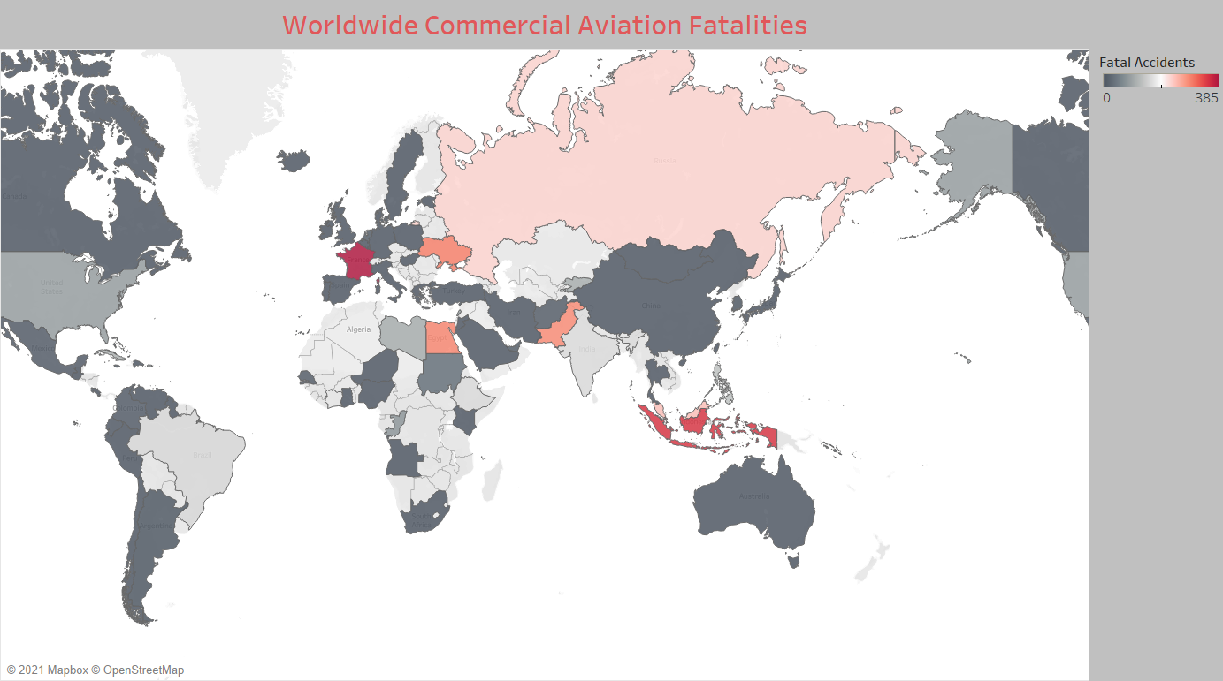

A second visualizations (“Most Popular Commercial Airliner Accidents

(U.S.) Boeing & Airbus”) shows the number of aviation accidents and fatalities by year. Although more data analysis is required to prove a quantifiable correlation between the two, the visualization does pass an obvious “eye-test” for correlation. The data that feed this has been filtered to reflect the aircraft platforms that one is likely to travel on by means of aviation travel.

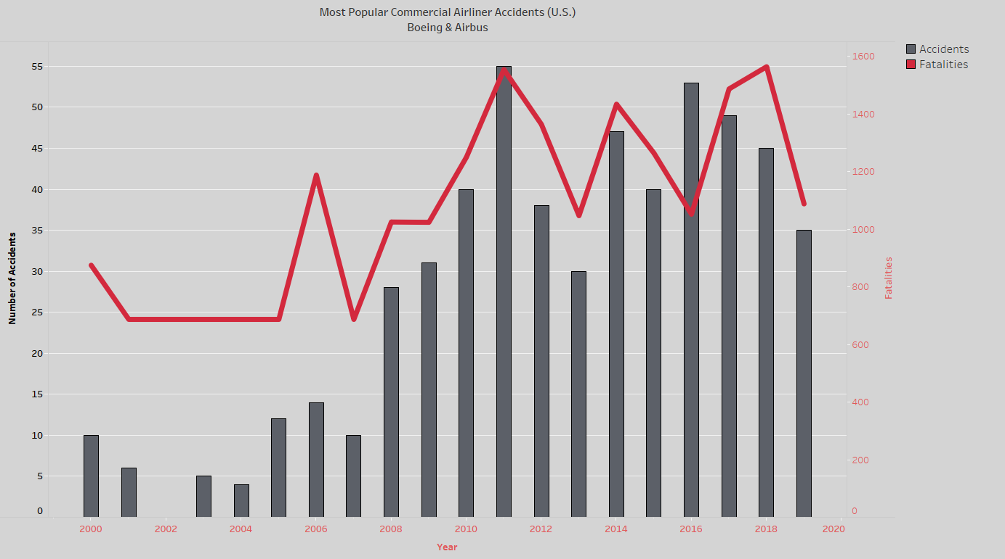

The last visualization (“Commercial Aviation vs Vehicle Fatalities (U.S)”) brings together the primary objective of this assignment. This visualization shows that both commercial aviation accidents and vehicle fatalities have remained constant since 2000. Thus, proving that aviation travel is by far the safest form of travel in comparison to vehicle/road travel.

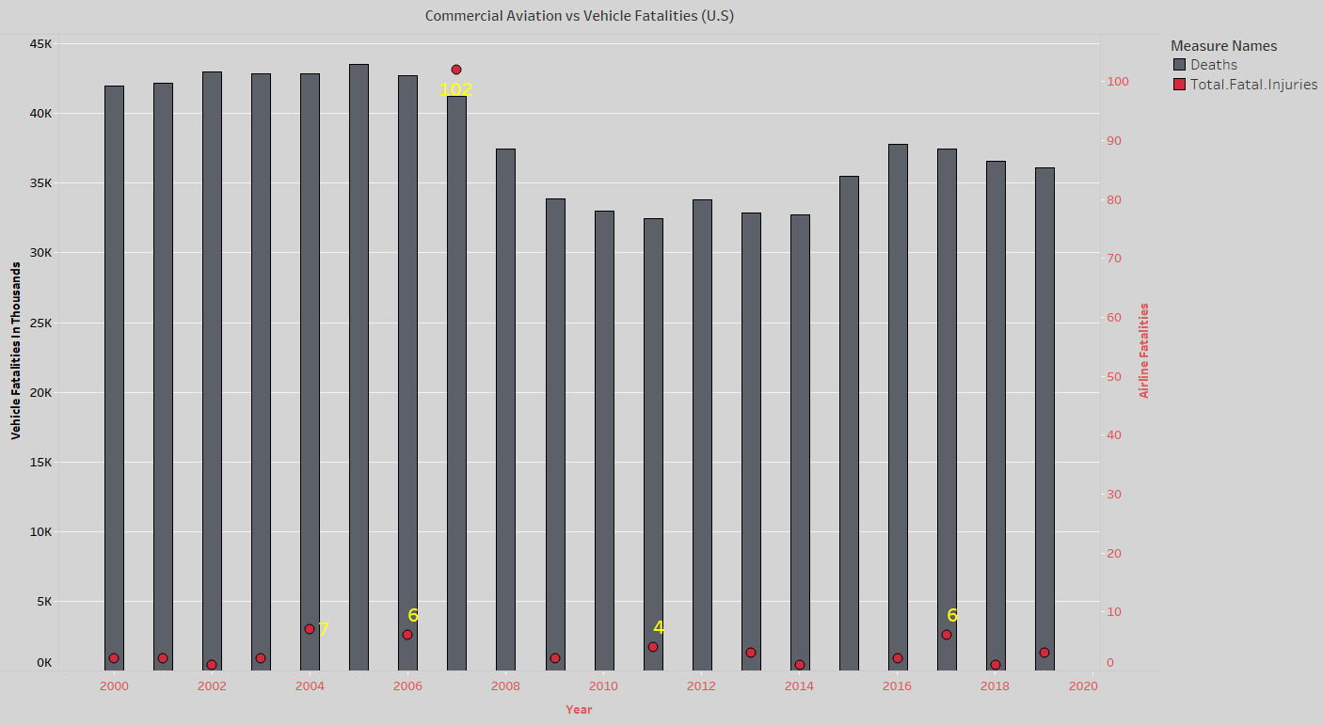

Slotnick, D. (2019, November 18). Boeing's 737 officially lost the title of world's most popular airplane. Airbus' competitor just passed it in sales. Retrieved January 10, 2021, from https://www.businessinsider.com/airbus-beats-worlds-most-popular-plane-a320-737-2019-11#:~:text=Airbus%20A320%20beats%20Boeing%20737%20as%20world's%20most%20popular%20plane%20%2D%20Business%20Insider&text=The%20word%20%22Insider%22.